10-12-2026
APAFR Fire Data: Comparing the New Fire Record with the Old
This report compares the new APAFR fire data (provided in September 2026) with the older fire data that we used in several published papers (Slocum et al. 2010a, 2010b; Slocum and Orzell 2013; Platt et al. 2015). Here we are examining this question: if we switch to the new data, will our results agree with the previous work?
We found that the years both records cover (FY1997 to FY2009), total area burned differs by about 3%. Part of that difference had to do with unknown fires. Also, the differences lie in a few years.
The upshot is that the new data set agrees with the old data enough that we can have high confidence that the new data set is of good quality and that there is not some processing errors affecting the results.
Data and data processing: The project for this analysis is called “FIRE.” In FIRE, I wrote a process creates the new data set (see below). This process has been ported over to the MWB project.
The old data is old_fire_data.csv (data/raw/fire/2010_fire_data/). It has one row per day with fire, giving area burned (ha) and number of fires for prescribed, ordnance, and lightning fires. It was compiled at some point from two SAS files (prescribedfires.sas7bdat and wildfires.sas7bdat); I checked, and the area totals in the CSV match the SAS files exactly. The record runs from October 1996 to September 2009.
With the old data, unknown fires were processed as detailed in an old report Tasks 1 - 7 v1.4 (final report) for a project assigned in 2005. I won’t go into detail here as this is beyond the scope of this report.
The new data is fire_data.gpkg (data/processed/fire/), produced by process_fire_data.py. It has one row per fire event from 1996 to 2025, with an ignition source of Prescribed, Military, or Lightning. “Military” in the new data corresponds to “ordnance” in the old.
With the new data a number of important decisions were made to address issues with unknown fires:
(1) It had a significant issue in that fires from 2006 to 2011 did not have an ignition source labeled for wildfires; that is, wildfires were not labeled as having a lightning or military ignition source. To address this, older yearly records (shapefiles) were used to label these fires from 2006 to 2009. For 2010 and 2011 we had to rely on a different method.
(2) Fires labeled as “jump” fires were assigned ignition sources according to whatever burned close to it on the same day or the day before. There was a large unknown fire that was specifically handled (a “fenceline” fire that neighbored a wildfire but which was, in fact, a prescribed fire.)
(3) Any other unknowns were labeled using a logistic regression model. This model was not super accurate, but it was accurate enough that some 800 hectares were at risk of being mislabeled.
Results: Here are the totals for FY1997–FY2009:
old_ha new_ha diff_ha diff_pct
Prescribed 125448 128814 3366 2.7
Military 18122 19408 1286 7.1
Lightning 6767 6666 -101 -1.5
Total 150336 154888 4551 3.0
Comparing new to old, prescribed fire is up 2.7%, military up 7.1%, and lightning down 1.5%. Overall, the new data has 3.0% more area burned than the old.
Broken down by fiscal year, most years agree to within about 130 ha in every category. The differences are concentrated:
- Prescribed: FY1999 (+1,057 ha), FY2006 (+987 ha), and FY2008 (+642 ha) account for about 80% of the prescribed difference.
- Military: nearly identical through FY2005, then it swings back and forth from FY2006 to FY2009 (−80, +806, −456, +677 ha).
- Lightning: nearly identical except FY2009 (−270 ha).

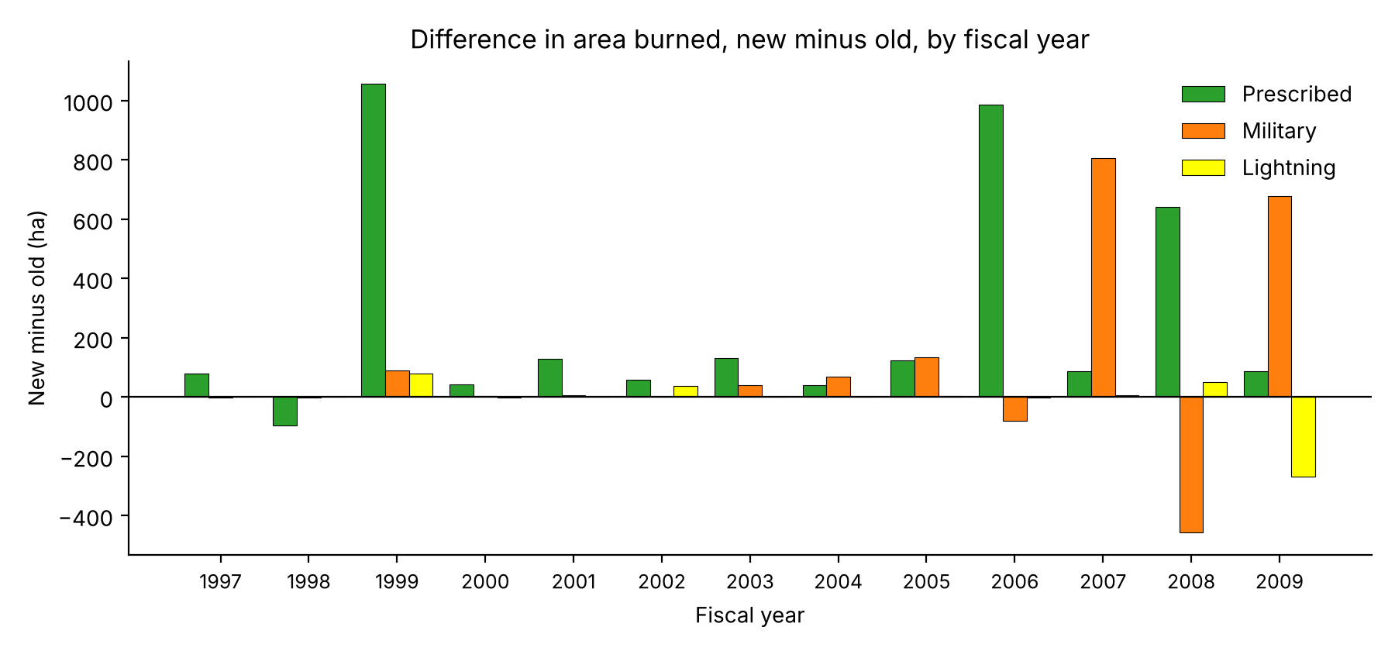
Difference by FY (new - old, ha)
FY Prescribed Military Lightning
1997 79 -1 -0
1998 -95 -1 -0
1999 1057 89 79
2000 42 3 -1
2001 128 7 -0
2002 59 -0 36
2003 131 41 -0
2004 40 68 -0
2005 123 133 2
2006 987 -80 -1
2007 88 806 7
2008 642 -456 49
2009 86 677 -270
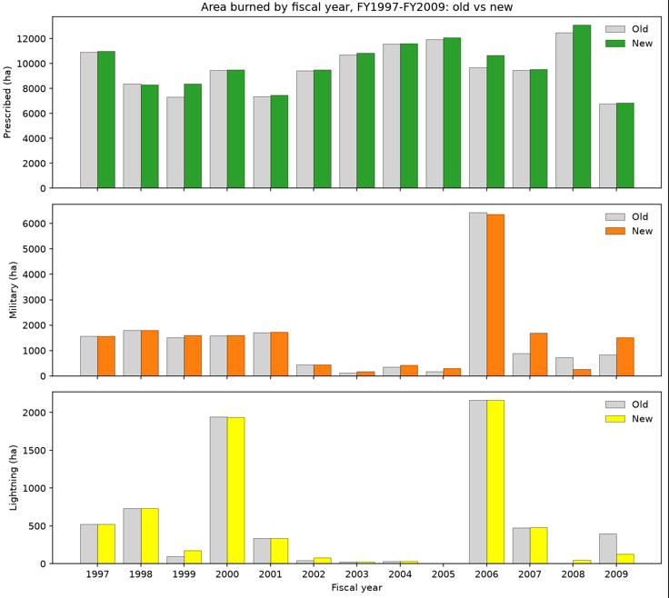
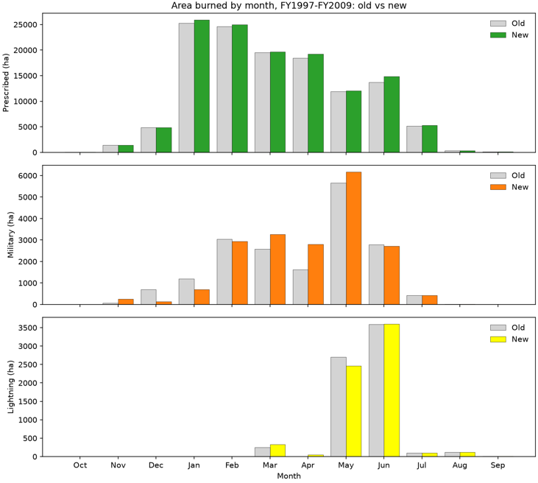
Why the differences: The main explanation appears to be in how the two sources handled unknown fires. Most of these are likely military, and military is the category that went up the most (+7%). FY2006–2009 is also the period when the master file lost ignition-source detail, so it is where the new data relies most on reconstruction (yearly files and the model). That fits the military swings in those years.
Conclusions: Our main concern is, is the new processing of the latest data of good quality? Because we know that the old data was processed with a high degree of diligence (we did, after all, publish a number of papers using it), if the new data agrees with it, that means we can have confidence in the new data.
I found that the new data agrees with the old data closely. Over FY1997–FY2009, total area burned is within 3%, prescribed fire within 3%, and lightning within 2%. The most important issue is
References:
Platt, W. J., S. L. Orzell, and M. G. Slocum. 2015. Seasonality of fire weather strongly influences fire regimes in South Florida savanna-grassland landscapes. PLoS ONE 10:e0116952.
Slocum, M. G., B. Beckage, W. J. Platt, S. L. Orzell, and W. Taylor. 2010a. Effect of climate on wildfire size: a cross-scale analysis. Ecosystems 13:828–840.
Slocum, M. G., W. J. Platt, B. Beckage, S. L. Orzell, and W. Taylor. 2010b. Accurate quantification of seasonal rainfall and associated climate–wildfire relationships. Journal of Applied Meteorology and Climatology 49:2559–2573.
Slocum, M. G., and S. L. Orzell. 2013. A structural equation model analysis of relationships among ENSO, seasonal descriptors and wildfires. PLoS ONE 8:e75946.

